NSID : jiz457

NAME : Zang, JiaWei

Step 1

Save all data of original database into sql and txt, to make sure that I don’ t lose anything.

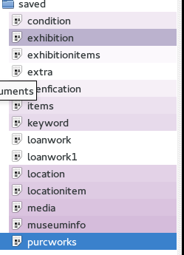

Step 2

Delete all original database by dbVisualizer or command line

PS: I Evaluated DbVisualizer to professional Version, then I could do actions.

Step 3

Run code again without extra works related to bonus question

Reset the database to be just have assignment 1 - 3 Because my database contain extra information about extra works by running original code I saved.

Step 4

Evaluation for Database structure, which does not contain extra works

By checking the code in extra work is there, including exhibitions which I added to test the cost. If there is not exhibition which I added in the extra section, then the Reset the database is evaluated.

Step 5

Create new Schemas and in this case named this called “test”, and let this schema to be temp schema the same database structure with team database. Use the original database and use sql query insert into the “test” schema same with the team database which including domain and tables

Step 6

Domains, I run the scripts which create domain on Dbvisualizer professional.

Step 7

**Transfer data into new database or new schema**

Owners

* To transfer original data into this table, I am using insert to into the new schema. Basically I am missing the state, street name, building number, so I leave those into empty. Insert rest of them into new table. Basically, I saved all the information about owner table, because, in this table I am not getting any issue.

Locations

* To transfer original data into this table, I am using the location table as source in my original schema, And only thing new for me is traveling exhibition location to this part I divided into two parts, one part is in Israel and one part is not. If a location city is not Israel then this location is traveling location.

Source from location table

Doors

* To transfer original data into this table, I am using door table which in original table in my original schema. Because these are similar, I just need to insert into new database with original table data. This table is same table I had.

Source from door table

Works

* To transfer original data into this table, I am using identification table and item table, because the type and sub type are changed,, so and I am using the sub type to check the physical property, for example, if the sub type is Asian Art Painting, then the physical property is Painting and the work classification will be same with the original sub type.
* The additional information the keyword is does not important (useless), they are all “ART” etc al. And this is does not mean anything.
* Therefore, I ignore this out of new schema.

Source from item and identification

Exhibitions

* My original table contain exhibition location information, therefore, I need to take those out.
* Because in this table, there is repeat exhibition entry in exhibition name attributes which called “TOP NOTCHED show”. For this record, I just take one. And I still missing the security person name, and my original table does not have it, but this record is important, therefore, I make it up.
* And, for the attributes which is called is traveling exhibition, they are all false by default, and I sql command.
* For the description, I just copy and paste from original exhibition description into new exhibition table. And for the attributes which called security person name I made this up, since I did have this one in my original database table.

Exhibition Locations

* This information was in exhibition table, therefore, I just get the exhibition and their location information into new exhibition location table.

Sponsor Exhibitions

* I was missing this sponsor for exhibition, therefore, I need to make the sponsor information first. In this case, I made the Bill and zang, Time up for the sponsor name.
* And I divided those into two part, one part is for the “'TOP NOTCHED show'”, because this there are two entries in original table,

Exhibition Works

* Using the sql query to new schema, I divided into two parts, and select from original tables.

Work owners

* Firstly, I insert data which is own by my museum, which is own by me all the time.
* Secondly, I insert data which are belonged to loaned work, which is mean the ownership is outside museum, which is mean that works ownership did change. And I find the assignment requirement, and set the start date and set the end date to be null.
* Thirdly, insert the date which is purchased and sold, in this case, I set the seller to be unknow and buyer to be unknow. And set the selling items for seller ownership end date to be '2016-10-25, and set the buyer ownership start date to be '2016-10-25, and set the end of ownership to be null and vise versa.

Themes

* In this new table, I insert the type item table from my original schema into this table.

Work locations

* In this new table, I insert this table from my original location item table by using the sql code.

Works insurance

* In this table, I am miss insurance value date start and end date, therefore, I made this up to be 2013 01 01 to 2022 01 01, which will be reasonable. And insert the insurance value from my original table which is called item table.

Works medium

* In this table, just insert my original data from media table.

Work transaction

* I am missing this table, because I am using the location item, condition, and item identification tables to holding this information. Therefore, I am using query select those information from the item condition and item identification.
* And I am missing the sold and purchase and loan or return information, in my case, I have P for purchase, SOD for sold, PB, and LB are for borrowed. And I add interval 12 hours, which make this to be into time stamp.
* I divided those into loan and return section, and purchase and sold section.
* And I for sold item, I have sold item for record.
* In this case, purchase item action is happen on 2016-10-25, then I insert this into new database. And insert add this into sold record by same record.
* In this case, sold item action is happen on 2016-10-21, then I insert this into new database. And insert add this into purchase record by same record.
* In this case, loan item action is happen on 2015-05-30, then I insert this into new database. And insert add this date into borrow record by same record.

PS: And I have loantable, keyword, loanwork, purwork table which is unimportant, and they are all repeat information. And keyword is useless for this situation because the information stored in this table are all “art”, “Israel”, therefore, I ignore the data stored in those table.

Step 7

**Evaluate** the data

Part A

**Preliminary Evaluation**

Evaluating the tables, domains and basic database elements.

* Evaluation Environment
  + Windows + putty / dbvisualizer
  + Linux + Command line / dbvisualizer
* Testing for team table and structure.
  + Reason I testing it is I need to make sure, team member won’t have trouble with the those.
  + Errors I found:
    - Repeat Domains
      * Fixed by delete those
    - Missing Constraints
      * Fixed by adding constraints
    - Missing keys in some table
      * Fixed by adding and update the key in those table.

Part B

**Team Peer Review Evaluation**

Let team member to read my records in the team database. And I got feedback from them.

* Evaluation Environment
  + Team members can access the team database
* Log: Mistake found in owner information, which should be only one to be my museum which is “Israel museum’
  + Fixed: By update the true into false excluding the israel museum
* Missing Phone number in owner information
  + Fixed: By update the information about the owner information

Part C

**Pre-Transfer Evaluation**

This testing or evaluation is for before I loading data into team database, I doing this testing because I don’t want to mass the team database.

* Evaluation Environment
  + Windows + putty / dbvisualizer
  + Linux + Command line / dbvisualizer
  + In cmpt355_jiz457 public schema
* Owner table
  + Query this table which is matching team database table
    - Check that the there is new attributes added on and there are 3 attributes are null, because those I did have it.
      * Evaluating source in additional file
* Check table structure contain all attributes
* Check empty attributes are missing, because I don’t have those
* Check email attribute which have this attributes
* Locations
  + Query this table which is matching team database table
    - Check table structure contain all attributes
      * Check all attributes is there, and check the data is correct
      * Check the travelling location is five.
* Doors
  + Query this table which is matching team database table
    - Check table structure contain all attributes
    - Check all attributes is there, and check the data is correct
      * Don’t need to check it because new team table and my original are same
* Works
  + Query this table which is matching team database table
    - Check table structure contain all attributes
    - Check all attributes is there, and check the data is correct
      * Check there is no record for 3 attributes
      * Check the physical property and work classification are matching
        + For example, Painting is match for Asian Art Painting and so on
* Exhibitions
  + Query this table which is matching team database table
    - Check table structure contain all attributes
    - Check all attributes is there, and check the data is correct
* Exhibition Locations
  + Query this table which is matching team database table
    - Check table structure contain all attributes
    - Check all attributes is there, and check the data is correct
      * Check that there are 17 record.
      * Check that there are 2 record for muti-room exhibition (in this case is should be 2)
* Sponsor Exhibitions
  + Query this table which is matching team database table
    - Check table structure contain all attributes
    - Check all attributes is there, and check the data is correct
* Exhibition Works
  + Query this table which is matching team database table
    - Check table structure contain all attributes
    - Check all attributes is there, and check the data is correct
    - Check there is entry museum is there
* Themes
  + Query this table which is matching team database table
    - Check table structure contain all attributes
    - Check all attributes is there, and check the data is correct
    - Check there is entry museum is there
* Work locations
  + Query this table which is matching team database table
    - Check table structure contain all attributes
    - Check all attributes is there, and check the data is correct
    - Check there is entry museum is there
* Work owners
  + Query this table which is matching team database table
    - Check table structure contain all attributes
    - Check all attributes is there, and check the data is correct
      * Check there is entry museum is there
* Works insurance
  + Query this table which is matching team database table
    - Check table structure contain all attributes
    - Check all attributes is there, and check the data is correct
      * Check there is entry museum is there
* Works medium
  + Query this table which is matching team database table
    - Check table structure contain all attributes
    - Check all attributes is there, and check the data is correct
      * Check there is entry museum is there
* Work transaction
  + Query this table which is matching team database table
    - Check table structure contain all attributes
    - Check all attributes is there, and check the data is correct
      * Check there are just four type in the transaction
      * Check the count of purchase and sold item records are the same
      * Check the count of loan and borrow item records

PS: Those evaluation is in additional file.

Part D

**Post-Transfer Evaluation**

This testing or evaluation is for after I loading data into database. Make sure my data is correct. AKA this test will check

* Evaluation Environment
  + Windows + putty / dbvisualizer
  + Linux + Command line / dbvisualizer
  + In cmpt355_jiz457 public schema
* Owner table
  + Query this table which is matching team database table
    - Check that the there is new attributes added on and there are 3 attributes are null, because those I did have it.
      * Evaluating source in additional file
* Check table structure contain all attributes
* Check empty attributes are missing, because I don’t have those
* Check email attribute which have this attributes
* Check the my data is there
* Locations
  + Query this table which is matching team database table
    - Check table structure contain all attributes
      * Check all attributes is there, and check the data is correct
      * Check the travelling location is five.
      * Check the my data is there
* Doors
  + Query this table which is matching team database table
    - Check table structure contain all attributes
    - Check all attributes is there, and check the data is correct
      * Don’t need to check it because new team table and my original are same
      * Check the my data is there
* Works
  + Query this table which is matching team database table
    - Check table structure contain all attributes
    - Check all attributes is there, and check the data is correct
      * Check there is no record for 3 attributes
      * Check the physical property and work classification are matching
        + For example, Painting is match for Asian Art Painting and so on
        + Check the my data is there
* Exhibitions
  + Query this table which is matching team database table
    - Check table structure contain all attributes
    - Check all attributes is there, and check the data is correct
    - Check the my data is there
* Exhibition Locations
  + Query this table which is matching team database table
    - Check table structure contain all attributes
    - Check all attributes is there, and check the data is correct
      * Check that there are 17 record.
      * Check that there are 2 record for muti-room exhibition (in this case is should be 2)
      * Check the my data is there
* Sponsor Exhibitions
  + Query this table which is matching team database table
    - Check table structure contain all attributes
    - Check all attributes is there, and check the data is correct
    - Check the my data is there
* Exhibition Works
  + Query this table which is matching team database table
    - Check table structure contain all attributes
    - Check all attributes is there, and check the data is correct
    - Check there is entry museum is there
    - Check the my data is there
* Themes
  + Query this table which is matching team database table
    - Check table structure contain all attributes
    - Check all attributes is there, and check the data is correct
    - Check there is entry museum is there
    - Check the my data is there
* Work locations
  + Query this table which is matching team database table
    - Check table structure contain all attributes
    - Check all attributes is there, and check the data is correct
    - Check there is entry museum is there
    - Check the my data is there
* Work owners
  + Query this table which is matching team database table
    - Check table structure contain all attributes
    - Check all attributes is there, and check the data is correct
      * Check there is entry museum is there
      * Check the my data is there
* Works insurance
  + Query this table which is matching team database table
    - Check table structure contain all attributes
    - Check all attributes is there, and check the data is correct
      * Check there is entry museum is there
      * Check the my data is there
* Works medium
  + Query this table which is matching team database table
    - Check table structure contain all attributes
    - Check all attributes is there, and check the data is correct
      * Check there is entry museum is there
      * Check the my data is there
* Work transaction
  + Query this table which is matching team database table
    - Check table structure contain all attributes
    - Check all attributes is there, and check the data is correct
      * Check there are just four type in the transaction
      * Check the count of purchase and sold item records are the same
      * Check the count of loan and borrow item records
      * Check the my data is there

PS: In Evaluation Team sql file, which should run on team08 server and in public schema.

Step 8

Export the schema, select the including data, select the SQL. and export the sql file

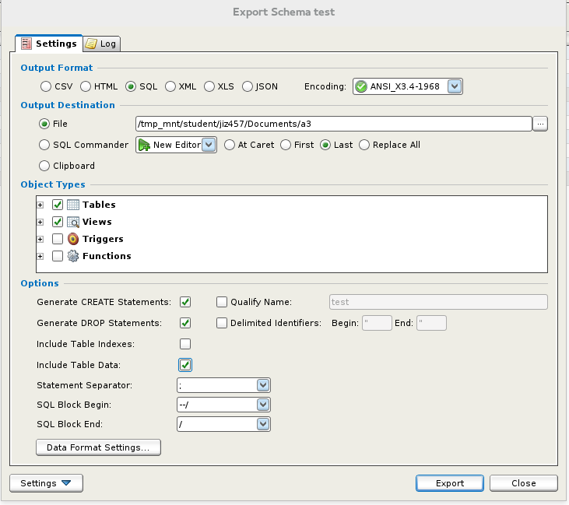

Step 9

Create new schema for the debugging the sql code is running perfectly

Debug the sql file, tried to run this file in SQL Commander three time.

Step 10

Import into team database

Step 11

Done.

**Steps to transfer data into team database**

Following the step 8, 9 and 10

AKA

Export my database into sql in Dbvisualizer

Then create schema in team server.

And run this in new schema in team server.

And query from this new schema and insert into team database.